Game Map
In-class Exercise, August 22nd, 2016
Full name of all group members (up to 4):
1 | 2
3 | 4
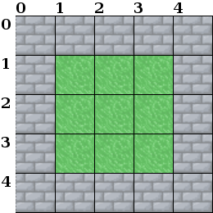
We are going to build a map for a video game. For this map, we're going to store a series of tiles in some structure, and represent in this structure what image is used in each space.
- The map is 5 tiles wide by 5 tiles tall
- Tiles can be either B for brick or G for grass.
- The tiles will be stored in some type of array.
If we stored this as a 2D array, it might look like this:

0,0 = B 1,0 = B 2,0 = B 3,0 = B 4,0 = B
0,1 = B 1,1 = G 2,1 = G 3,1 = G 4,1 = B
0,2 = B 1,2 = G 2,2 = G 3,2 = G 4,2 = B
0,3 = B 1,3 = G 2,3 = G 3,3 = G 4,3 = B
0,4 = B 1,4 = B 2,4 = B 3,4 = B 4,4 = B
1. For the 2D array, write an if, else statement that will set a tile to either B or G. The input is the two indices (x, y) of the tile, and the output is either B or G.

2. Draw a 1D array that represents the same map. Instead of having two indices ([x][y]), you will only have one index (i), going from 0 to 24. Write down each tile's index, and its value (B or G)

3. Map each (x,y) index from the 2D array to the index (i) of the same tile in the 1D array.
0, 0 = 0 | 1, 0 = 1 | 2, 0 = 2 | 3, 0 = 3 | 4, 0 = 4
0, 1 = | 1, 1 = | 2, 1 = | 3, 1 = | 4, 1 =
0, 2 = | 1, 2 = | 2, 2 = | 3, 2 = | 4, 2 =
0, 3 = | 1, 3 = | 2, 3 = | 3, 3 = | 4, 3 =
0, 4 = | 1, 4 = | 2, 4 = | 3, 4 = | 4, 4 =

4. Using the map from #3, can your group figure out an equation to get the (x, y) index of the 2D array, using the index from the 1D array? Input is (x,y), output is index (i).
Start by figuring out a pattern, and derive as much as you can for a formula. (Hint: use modulus!)

X =

Y =

